DATE 31.05.2019
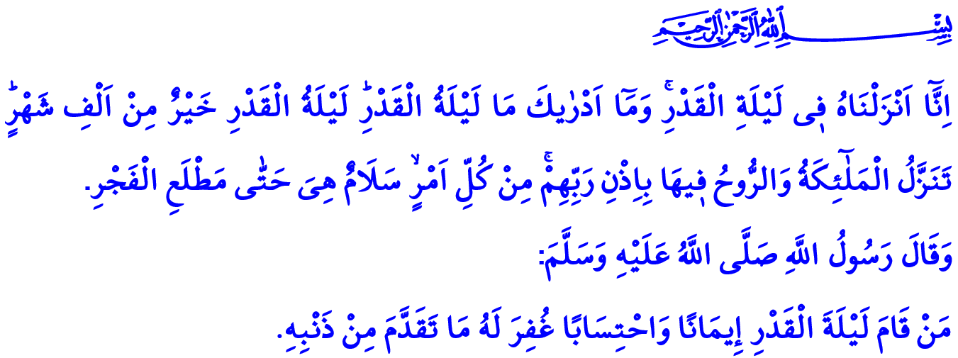 LAILAT AL-QADR:
THE NIGHT HONORED BY THE QUR’AN
Honorable Muslims!
Let us give ear to these verses of Allah the Almighty (swt) on this blessed Friday while we are approaching the end of the month of Ramadan: “We have indeed revealed this (message) in the Night of Qadr (Power). And what will explain to thee what the Night of Qadr is? The Night of Qadr is better than a thousand months. Therein come down the angels and the Spirit by Allah’s permission, on every errand: Peace!.. This until the rise of the Morn!”
Let us set our hopes on the glad tidings of Prophet Muhammad (saw) in this sacred time of Friday: “Whoever passes Lailat al-Qadr in prayer with faith and seeking his reward from Allah will have his past sins forgiven.”
Dear Believers!
We are going to attain the Night of Qadr tonight insha’Allah. It is a unique night which brought the forgiveness of al-Rahman and the light of the Qur’an to humanity. Every believer who appreciates the value of this exceptional period of time and wishes to spend it in an effective and meaningful way must first turn their steps towards the Qur’an. They should remember once again that reciting the Holy Qur’an beautifully, and understanding and applying it in our lives in the best way are the main purposes of life. If we want to enlighten our lives and add barakah to it with the Qur’an, Lailat al-Qadr is the best opportunity.
In that case, let us take this opportunity to contemplate some of the verses from the Holy Qur’an which invite us to hidayah (guidance to the true path) and to the truth.

“Is it not to Allah that sincere devotion is due?” Muslims who comprehend that neither humans are created in vain nor they are left unattended after creation be the servants to only Allah (swt). They stay away from all kinds of arrogance and show-off, and live in ikhlas (pure intention) and sincerity. They reflect on their lives the promise that they gave by believing with their worships and the morality of the Qur’an.
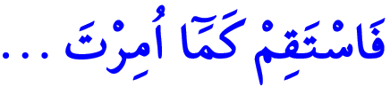
“Therefore stand firm (in the straight Path) as thou art commanded.” Muslims take our beloved Prophet Muhammad (saw) as an example in every phase of life and they become honest like him. They try not to get off the direction, the right and the truth. They know that lies, slander and betrayal can never exist together with iman. They do not compromise on righteousness.
“Allah doth command you to render back your trusts to those to whom they are due; and when ye judge between man and man, that ye judge with justice.” Our lives, our property and our family are entrusted to us. The nature, with its plants, animals, water, and soil, is entrusted to us. Reconstruction and management of the earth with justice, peace, and goodness are entrusted to us. A virtuous Muslim gives the trusts to those to whom they are due and sustains justice.
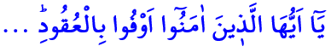
“O ye who believe! Fulfill (all) obligations.” Mu’min (believer) means the one who is trustworthy. When they promise, they keep their promises. Besides obeying the commands and prohibitions of Allah (swt), they also fulfill the requirements of the promises and agreements they make with people. Believers know that lying when one speaks, not keeping promises, and betraying what is entrusted are the signs of the hypocrites.
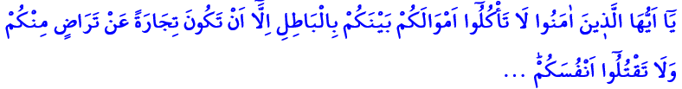 “O ye who believe! Eat not up your property among yourselves in vanities; but let there be amongst you traffic and trade by mutual good will: nor kill (or destroy) yourselves.” Muslims obtain their rizq (sustenance) by halal means and do not get involved in forbidden means in trade. They do not resort to void practices such as theft, extortion, bribery, usury, pawnbroking, gambling, unreasonable prices, and deception.
“And remember your Lord caused to be declared (publicly): ‘If ye are grateful, I will add more (favors) unto you; but if ye show ingratitude, truly my punishment is terrible indeed.’” Believers, who sustain their lives by countless blessings of Allah (swt), use the opportunities in their hands in accordance with the consent of the Almighty Allah (swt). The gratitude of wealth is to spend it in the way of Allah (swt), that of scholarship is to use knowledge for the benefit of humanity, and that of health is to serve in the path of benevolence and goodness.
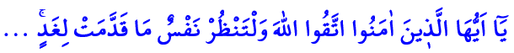
“O ye who believe! Fear Allah, and let every soul look to what (provision) it has sent forth for tomorrow.” Muslims know that you shall reap what you sow and that the Hereafter awaits us after this worldly life. When they have the opportunity, they ask themselves how prepared they are for the Hereafter. As they walk the path determined by the Qur’an to achieve eternal salvation, they set their target as the happiness in the Hereafter.
Honorable Muslims!
We can appreciate the value of Lailat al-Qadr only by truly appreciating the value of the Qur’an. Then let us connect our minds and our hearts to the Qur’an with the occasion of this night when the Holy Qur’an was revealed. Let us read the Qur’an more, exert effort to understand it, and try to live according to it and help others follow the same path. Let us consider the Night of Qadr as an opportunity for self-accounting, and asking forgiveness and mercy for our sins. Let us cherish every night and know the value of every blessing to add barakah to our whole life. Let us by this way benefit from the spiritual rewards of this night of grace and gifts, which is better than a thousand months.
Dear Believers!
I would like to make an important reminder as I conclude my khutbah. There are only a few days left for us to reach the eid. Many of us are going to set off as of today to spend the eid with the loved ones. The intensity of traffic flow on the roads requires us to be more careful than ever. Because the traffic accidents turn our joy of eid into sadness, and, as a nation, we all feel grief in our hearts. Many brothers and sisters are dying in accidents that occur due to speed violation, improper overtaking, close follow-up, fatigue, etc. Many families are destroyed due to these incidents. At this point, I invite all our brothers and sisters to obey the traffic rules, to be patient, sympathetic and careful, and to respect each other’s rights and law.

Qadr, 97/1-5.
Bukhari, Fadlu Lailat al-Qadr, 3.
Zumar, 39/3.
Hud,11/112.
Nisa,4/58.
Ma’idah 5/1.
Nisa,4/29.
Ibrahim,14/7.
Hashr, 59/18. General Directorate of Religious Affairs

